i

**LAB REPORT**

***Submitted by***

**ANANYA PANDIT [RA2111030010126]**

***Under the Guidance of***

**Dr. Gouthaman. P**

##### Assistant Professor, Department of Networking and Communications

***In partial satisfaction of the requirements for the degree of***

**BACHELOR OF TECHNOLOGY**

### in

**COMPUTER SCIENCE AND ENGINEERING**

**with specialization in CYBERSECURITY**



**SCHOOL OF COMPUTING**

**COLLEGE OF ENGINEERING AND TECHNOLOGY SRM INSTITUTE OF SCIENCE AND TECHNOLOGY KATTANKULATHUR - 603203**

**MAY 2023**

ii

### COLLEGE OF ENGINEERING & TECHNOLOGY SRM INSTITUTE OF SCIENCE & TECHNOLOGY

S.R.M. NAGAR, KATTANKULATHUE – 603 203 Chengalpattu District

# BONAFIDE CERTIFICATE

### Register No. RA2111030010126 Certified to be the

bonafide work done by ANANYA PANDIT of II Year/IV Sem B.Tech

Degree Course in the **Practical Course – 18CSC206J - Software Engineering and Project Management** in **SRM INSTITUTE OF SCIENCE AND TECHNOLOGY,** Kattankulathur during the academic year 2022 – 2023.

##### SIGNATURE

Faculty In-Charge **Dr. Gouthaman. P** Assistant Professor

Department of Networking and Communications SRM Institute of Science and Technology

##### SIGNATURE

**HEAD OF THE DEPARTMENT**

##### Dr. Annapurani Panaiyappan. K

Professor and Head,

Department of Networking and Communications SRM Institute of Science and Technology

iii

i

**ABSTRACT:**

### This abstract describes an online auction system that allows customers to bid and upload items from the comfort of their homes. The system aims to provide a hassle-free experience for customers, who can easily browse through the available products, bid on their orders, and have the items delivered to their doorstep. The system is designed to be user-friendly, with a simple and intuitive interface that allows customers to easily navigate through the website. The system is also equipped with features such as real- time inventory management, secure payment processing, and a reliable delivery network to ensure that customers receive their orders in a timely and efficient manner. The system aims to promote auctioning services by providing customers with access to a wide range of products of high value. Overall, this online auction system offers a convenient and reliable way for customers to access auctioning services.

iv

ix

**TABLE OF CONTENTS**

|  |  |  |
| --- | --- | --- |
| EXPERIMENT NO | TITLE | PAGE NO |
|  | ABSTRACT |  |
|  | LIST OF FIGURES |  |
|  | LIST OF ABBREVIATIONS |  |
| 1 | PROBLEM STATEMENT |  |
| 2 | STAKEHOLDERS AND PROCESS MODELS |  |
| 3 | IDENTIFYING REQURIMENTS |  |
| 4 | PROJECT PLAN AND EFFORT |  |
| 5 | WORK BREAKDOWN STRUCTURE & RISK  ANALYSIS |  |
| 6 | SYSTEM ARCHITECTURE, USE CASE & CLASS DIAGRAM |  |
| 7 | ENTITY RELATIONSHIP DIAGRAM |  |
| 8 | DATA FLOW DIAGRAM |  |
| 9 | SEQUENCE & COLLABORATION DIAGRAM |  |
| 10 | DEVELOPMENT OF TESTING |  |
| 11 | FRAMEWORK/USER INTERFACE |  |
| 12 | TEST CASES & REPORTING ARCHITECTURE/DESIGN/FRAMEWORK/IMPLE  -MENTATION |  |

v

##### LIST OF FIGURES

|  |  |  |
| --- | --- | --- |
| **FIGURE NO** | **TITLE** | **PAGE-NO** |
| **5.1** | **TIMELINE GANTT CHART** |  |
| **6.1** | **USECASE DIAGRAM** |  |
| **6.2** | **CLASS DIAGRAM** |  |
| **7.1** | **ENTITY RELATION DIAGRAM** |  |
| **8.1** | **DATAFLOW DIAGRAM (LEVEL:0)** |  |
| **8.2** | **DATAFLOW DIAGRAM(LEVEL:1)** |  |
| **9.1** | **SEQUENCE DIAGRAM** |  |
| **9.2** | **COLLABORATION DIAGRAM** |  |
| **12.1** | **PRODUCT CATALOGUE MODULE** |  |
| **12.2** | **ORDER MANAGEMENT MODULE** |  |
| **12.3** | **CUSTOMER SUPPORT MODULE** |  |

vi

##### LIST OF ABBREVIATIONS API-APPLICATION PROGRAM.

**UI-USER INTERFACE UX-USER EXPERIENCE**

##### CDN-CONTENT DELIVERY NETWORK

**PCIDSS-PAYMENT CARD INTERFACE DATA SECURITY STANDARDS.**

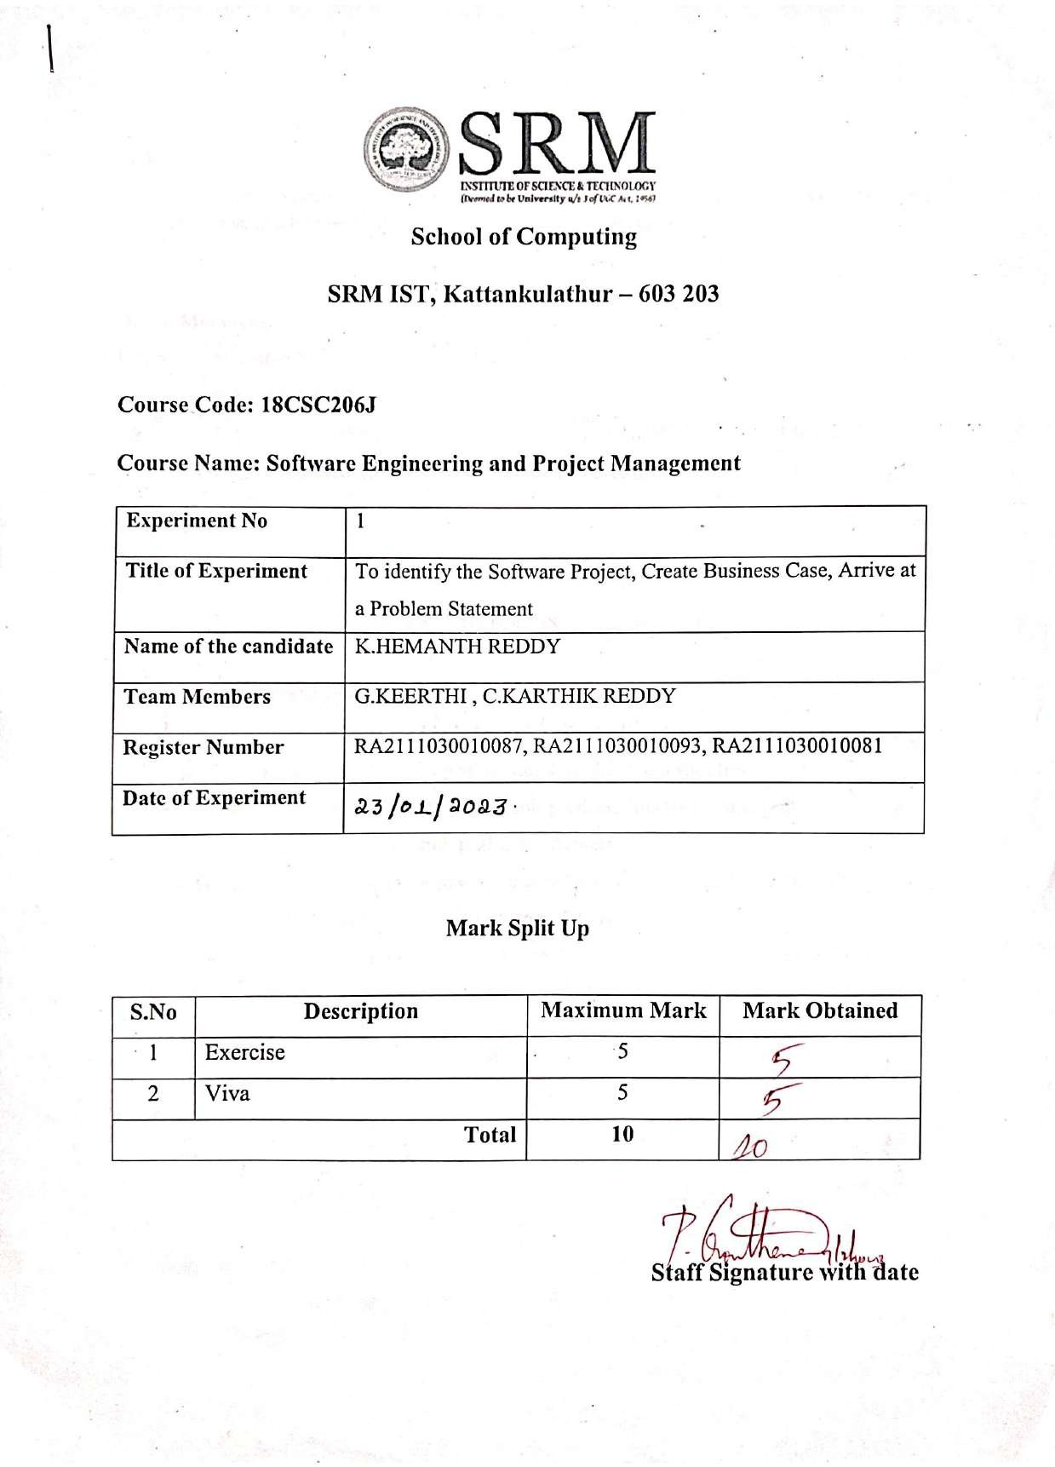

### 1

##### Aim

To Frame a project team, analyze and identify a Software project. To create a business

case and Arrive at a Problem Statement for the <title of the project>

##### Team Members:

|  |  |  |  |
| --- | --- | --- | --- |
| **S. No** | **Register No** | **Name** | **Role** |
| **1** | RA2111030010093 | G.KEERTHI | **Lead/Rep** |
| **2** | RA2111030010081 | C.KARTHIK REDDY | **Member** |
| **3** | RA2111030010087 | K.HEMANTH REDDY | **Member** |

**PROJECT TITLE :** FRESH FARMORG FOODS

##### PROJECT DESCRIPTION:

* We live in a digital age, and let’s face it— An Online Agriculture Shopping app is a platform for buying and selling agricultural products and supplies.
* The app would allow farmers to sell their produce directly to consumers, bypassing traditional intermediaries and profits for farmers.
* The main objective of the Online Vegetable Store **is** to manage the details of Vegetables, Customer, ,Order, Transaction, Payment.
* It manages all the information about Vegetables, Stocks, Payment, Vegetables.
* The project is totally built at administrative end and thus only the administrator is guaranteed the access.

# FRESH FARMORG FOODS SHOPPING TEMPLATE



|  |  |
| --- | --- |
| **DATE** |  |
| **SUBMITTED BY** | GURUGUBELLI KEERTHI (RA2111030010093)/Leader  Team Mates :  C.KARTHIK REDDY (RA2111030010081)/member K.HEMANTH REDDY (RA2111030010087)/member |
| **TITLE / ROLE** | **Project Title :**FRESH FARMORG FOODS  **Role :**TO SELL THE FRESH FARM VEGETABLES AND FRUITS DIRECTLY FROM FARMERS TO PEOPLES USING ONLINE APP |

**THE PROJECT**

* + The fresh farmorg foods Project is an E-Commerce platform for buying and selling fresh farm vegetables and fruits .
  + The main goal of the project is to create a platform for farmers, agribusinesses, and consumers to connect and transact directly without intermediaries.

**THE HISTORY**

* The Easton Farmers' Market is the oldest, continuously operating open-air market in the nation, and its location is the site of one of the only public readings of the Declaration of Independence.
* Farmers markets are a critical ingredient to our nation's food system.

**DISADVANTAGES:**

* **Technical Issues:** Technical issues such as slow loading, website crashes, and connectivity issues can disrupt the user experience and discourage people from using the app.
* **Data Security Concerns:** Shopping online requires sensitive information such as personal details, bank account numbers, and credit card details, which can make users wary of the security of their data.
* **Trust Issues:** Customers may not trust the app or its sellers to deliver the products as advertised or in a timely manner, leading to dissatisfaction with the shopping experience.
* **Limited Product Availability:** If the app only offers products from specific areas or suppliers, it may limit the availability of products for customers and make it difficult for them to find what they are looking for.
* **Poor User Experience**: If the app is difficult to navigate, confusing, or does not provide adequate information on products and services, users may become frustrated and abandon the app.
* **Delivery Delays**: Delivery delays can be a major problem for online shopping, particularly in rural areas where the delivery infrastructure is not well developed.
* **High Shipping Costs**: Shipping costs can be a major drawback for online shopping, as customers may have to pay more for shipping than they would in a physical store.
* **Poor Customer Service:** Poor customer service can result in dissatisfied customers who may leave negative reviews and discourage others from using the app.

##### APPROACH:

* Use email offers, text messages, or updates to promote your booth. Encourage customers to visit your farmer's market using quick location or sale notification updates.
* You can also host friendly games and invite your friends, neighbors, and family to enjoy a few meals of the foods you offer.

.

* Gather & analyze reliable market data. The first step to implementing an effective marketing campaign is to know who you're going after. ...
* Market to specific segments of farmers. ...
* Leverage data-targeted, omnichannel marketing.

**BENEFITS:**

* + Find Seasonal Fruits & Veggies. ...
  + Get the Freshest Produce Possible. ...
  + Cut Your Ecological Footprint. ...
  + Opt for Organic. ...
  + Make Friends with Your Farmers. ...
  + Get Expert Advice. ...
  + Grow Awareness. ...
  + Feel the Love.

##### Result :

Thus, the project team formed, the project is described, the business case was prepared and the problem statement was arrived.



5

##### Aim

To identify the appropriate Process Model for the project and prepare Stakeholder and User

––Description.

##### Team Members:

|  |  |  |  |
| --- | --- | --- | --- |
| **Sl No** | **Register No** | **Name** | **Role** |
| **1** | **RA2111030010093** | **G. KEERTHI** | **Rep/Member** |
| **2** | **RA2111030010081** | **C.KARTHIK REDDY** | **Member** |
| **3** | **RA2111030010087** | **K. HEMANTH REDDY** | **Member** |

**Project Title: FRESH FARMORG FOODS**

##### Selection of Methodology: AGILE METHODOLOGY

* For this project we select agile methodology because this methodology helps us to involves constant collaboration with stake holders because this project should be update constantly and it needs constant collaboration stake holders then only this project will be successful and in this methodology.
* We can change the plan and design by the review of the customers and to launch the new updates to project.

|  |  |  |  |  |
| --- | --- | --- | --- | --- |
| **Stakeholder Name** | **Activity/ Area /Phase** | **Interest** | **Influence** | **Priority (High/ Medium/ Low)** |
| **OWNER** | TO ACHIEVE GOALS AND TO INCREASE  THE SALES MANAGE KEY RELATION SHIP IN THE COUNTRY | HIGH | HIGH | 1 |
| **INVESTORS** | TO PROVIDE FINANCIAL RESOURCES | MEDIUM | HIGH | 1 |
| **SPONSOR** | TO ATTRACT THE PEOPLE, BUY THE PRODUCTS AND PUBLICITY AND HELPS FOR THE FUNDING | MEDIUM | MEDIUM | 3 |
| **SALES AND MARKETING** | TO PROMOTE THE PRODUTS IN WIDE RANGE USING THE APP AND SOCIAL MEDIA | LOW | MEDIUM | 3 |
| **GENERAL MANAGER** | TO MAINTAIN A WORKFUL RELATIONSHIP BETWEEN SUPPLIERS  AND DELIVERY PATRNERS | MEDIUM | HIGH | 3 |
| **CUSTOMER** | PURCHASING THE PRODUCT  AND LEAVING A FEEDBACK ABOUT THE SERVICES | HIGH | HIGH | 2 |
| **SUPPLIERS** | TO SUPPLY THE REQUIRED PRODUCTS | HIGH | MEDIUM | 4 |
| **DELIVERY PARTNERS** | TO DELIVER THE ORDERED PRODUCTS TO THE CUSTOMER IN TIME | HIGH | MEDIUM | 3 |

**RESULT:** Thus the Project Methodology was identified and the stakeholders were described

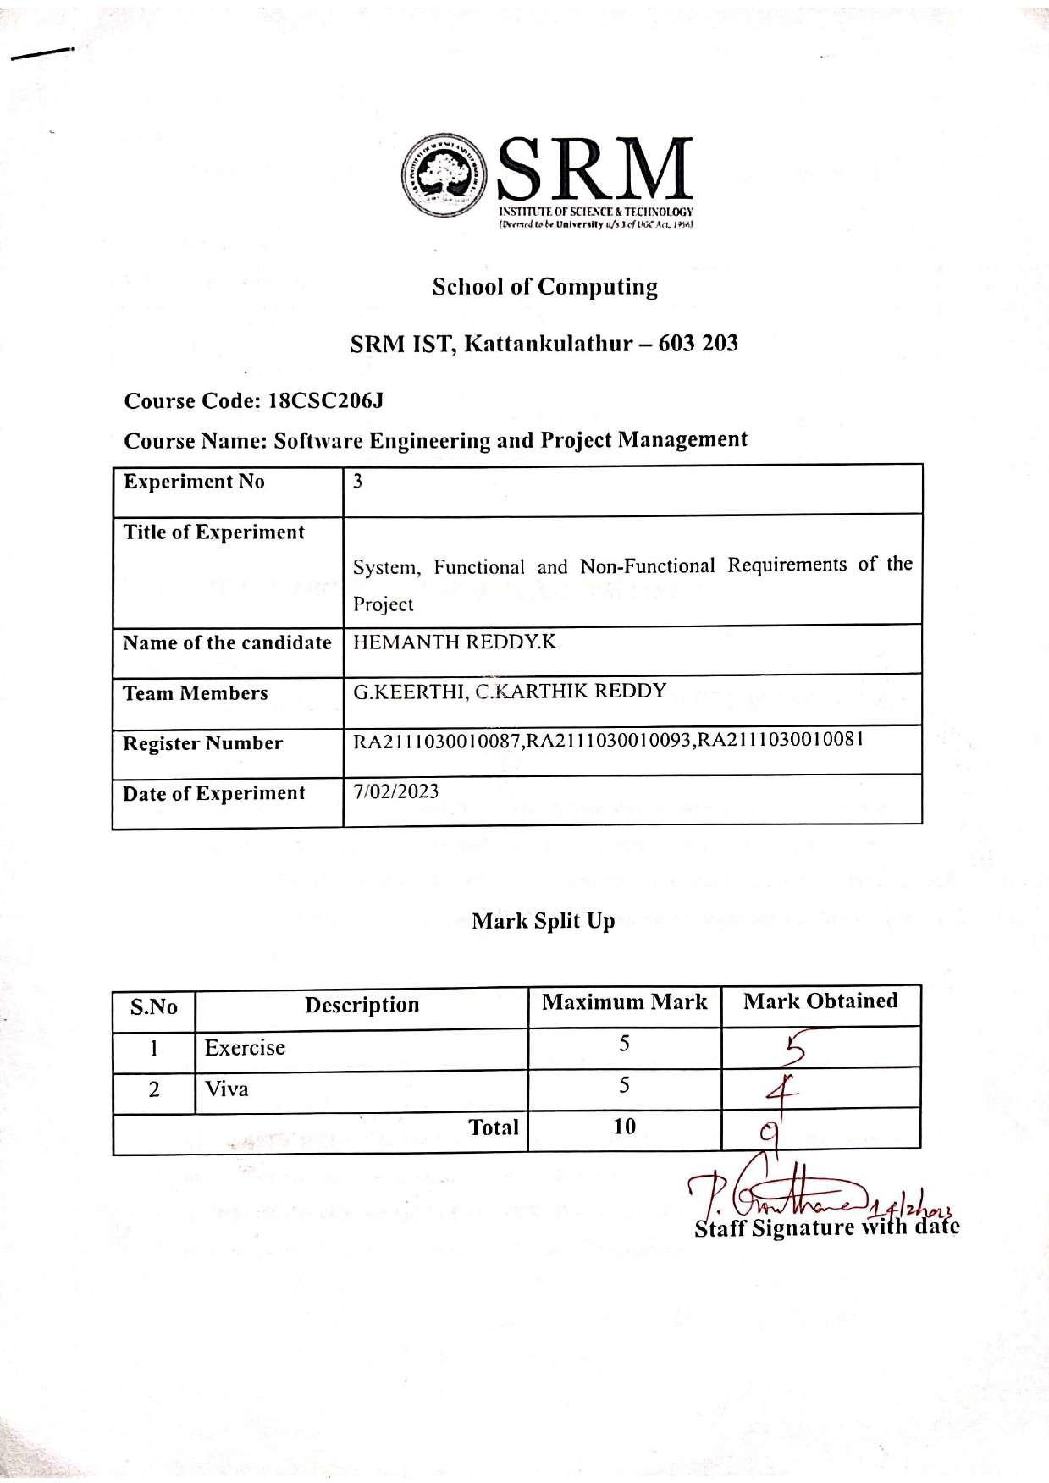

### 8

**Aim**

To identify the system, functional and non-functional requirements for the project.

**Team Members:**

|  |  |  |  |
| --- | --- | --- | --- |
| **S No** | **Register No** | **Name** | **Role** |
| **1** | RA2111030010093 | G.KEERTHI | Rep/Member |
| **2** | RA2111030010087 | K.HEMANTH REDDY | Member |
| **3** | RA2111030010081 | C.KARTHIK REDDY | Member |

**TITLE OF THE PROJECT : FRESH FARMORG FOODS**

**SYSTEM REQUIREMENTS:**

**THE SYSTEM REQUIREMENTS FOR THE FRESH FARM ORG FOODS ARE AS FOLLOWS:**

* + **HARDWARE REQUIREMENTS:** The system should have a high performance computer with sufficient RAM and storage to support the application and database
  + **SOFTWARE REQUIREMENTS**: The system should be built on a robust platform such as Java or Python, with a relational database management system such as MySQL or PostgreSQL.
  + **NETWORK REQUIREMENTS**: The system should be connected to the internet with a fast and reliable connection to ensure smooth operation.
  + **USER REQUIREMENTS:** The system should be accessible to customers through a web browser and also through a mobile app.
  + **SECURITY REQUIREMENT**S: The system should have robust security measures in place, including SSL encryption, secure authentication, and authorization mechanisms.
  + **PERFORMANCE REQUIREMENTS**: The system should be able to handle large amounts of traffic and transactions with minimal downtime.
  + **RELIABILITY REQUIREMENTS**: The system should be highly available and provide seamless performance, even during high-traffic periods.
  + **MAINTENANCE REQUIREMENTS**: The system should be easy to maintain and upgrade, with clear documentation and support for system administrators.
  + **COMPATIBILITY REQUIREMENTS:** The system should be compatible with different operating systems, web browsers, and devices.
  + **TECHNICAL SUPPORT REQUIREMENTS:** The system should have a reliable support system in place, including a help desk, online documentation, and knowledge base
  + **FUNCTIONAL REQUIREMENTS FOR FRESH FARMORG FOODS :**
  + User registration and login system for customers to place orders.
  + Product catalog management system to display and manage the food items.
  + Order management system to keep track of the orders placed by customers.
  + Payment gateway integration to process online payments.
  + Inventory management system to keep track of the available stock.
  + Order tracking system to allow customers to track their orders.
  + Delivery management system to manage the delivery of food items.
  + Customer support system to handle customer inquiries and complaints.
  + Reports generation system to track sales, inventory and customer behavior.
  + Marketing and promotion management system to launch promotions and offer discounts.
  + **NON FUNCTIONAL REQUIREMENTS OF THE FRESH FARMORG FOODS:**
  + User interface must be user-friendly, easy to use and visually appealing.
  + The system should be scalable to accommodate future growth.
  + The system must have a high level of security to protect sensitive customer and business data.
  + The system should have a fast response time and be available 24/7.
  + The system should be compatible with different devices and platforms.
  + The system must be able to handle high traffic volume
  + The system must be tested and validated to ensure high-quality performance.
  + The system should be easy to maintain and update.
  + The system must comply with industry standards and regulations
  + The system should provide real-time updates to all stakeholders.

**RESULT:**Thus the requirements were identified and accordingly described.

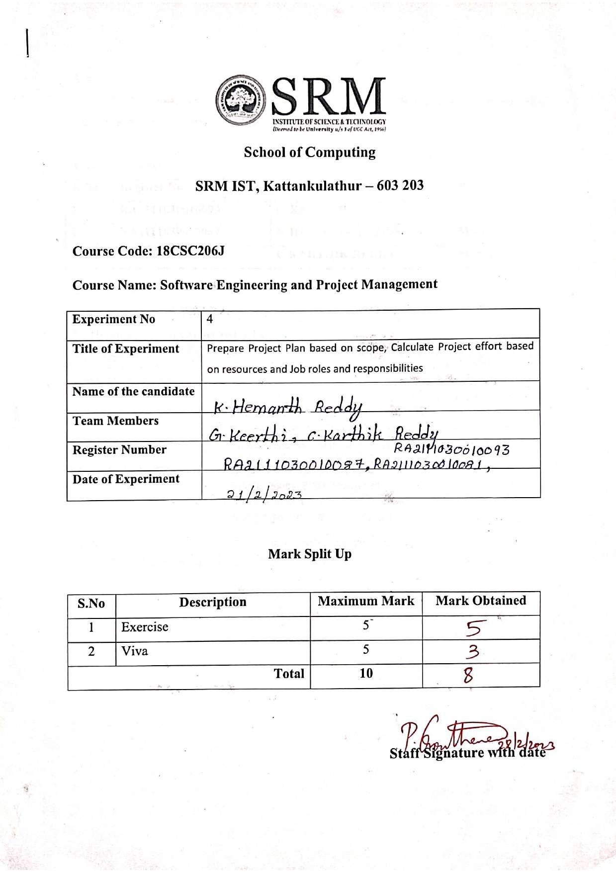

### 12

##### Aim

To Prepare Project Plan based on scope, Calculate Project effort based on resources, Find

Job roles and responsibilities

##### Team Members:

|  |  |  |  |
| --- | --- | --- | --- |
| **Sl No** | **Register No** | **Name** | **Role** |
| **1** | **RA2111030010093** | **G.KEERTHI** | **Lead** |
| **2** | **RA2111030010087** | **K.HEMANTH REDDY** | **Member** |
| **3** | **RA2111030010081** | **C.KARTHIK REDDY** | **Member** |

1. Project Management Plan

|  |  |
| --- | --- |
| **Focus Area** | **Details** |
| Quality Management | Quality Assurance: Quality assurance will be managed including governance, roles and responsibilities, tools and techniques and reporting  Quality Control: Specify the mechanisms to be used to measure and control the quality of the work products |
| Resource Management | Estimate and Manage the need People: People & Skills Required Finance: Budget Required  Physical: Facilities, IT Infrastructure |
| Risk Management | Identifying, analysing, and prioritizing project risks |

##### RISK MANAGEMENT:

|  |  |  |  |
| --- | --- | --- | --- |
| **RISK** | **Likelihood** | **Impact** | **Mitigation** |
| **Delayed Project Delivery Due to Technical Issues** | Medium | High | Regular system and infrastructure audits, proactive identification of technical issues and their resolution, contingency planning |
| **Security Breach or Data Theft** | Medium | High | Implementation of robust security measures such as firewalls, encryption, and access controls, regular security audits and updates, regular employee training on  security best practices |
| **Inadequate User Adoption High** | HIGH | Medium | Effective marketing and user outreach strategies, regular user feedback and analysis, continuous improvement of user experience |
| **Regulatory and Compliance Issues** | Low | High | Regular compliance audits and updates, staying up-to-date with regulatory requirements, maintaining transparency and accountability |
| **Budget Overruns** | Medium | High | Effective cost estimation and monitoring, proactive risk management, contingency planning, ongoing cost optimization |
| **Talent Attrition** | Low | Medium | Regular employee engagement and retention programs, backup resources and succession planning, ongoing employee  training and development |
| **Vendor Dependence** | Low | Medium | Diversifying vendor partnerships, effective vendor management and communication, ongoing evaluation and review of  vendor performance |

1. **RESOURCE MANAGEMENT:**

|  |  |  |
| --- | --- | --- |
| **Resource** | Responsibilities | Allocation |
| **Project Manager** | Oversees the project, creates project plan and timeline, manages budget and resources, ensures project meets goals and objectives Full-time | Full-time |
| **Business Analyst** | Analyzes business requirements, defines functional and non-functional requirements, creates use cases and user stories, supports testing and quality assurance | Full-time |
| **UX/UI Designer** | Designs user interface and user experience, creates wireframes and prototypes, conducts user testing and feedback analysis | Full-time |
| **Front-end Developer** | Develops the front-end of the web application, implements user interface design, ensures cross-browser compatibility, supports testing and  quality assurance | Full-time |
| **Back-end Developer** | Develops the back-end of the web application, creates database schema and API endpoints, ensures scalability and performance, supports testing and  quality assurance | Full-time |
| **Quality Assurance Engineer** | Develops test plans and test cases, executes manual and automated testing, identifies and reports defects, supports continuous integration and delivery | Full-time |
| **Technical Writer** | Creates technical documentation, user manuals, and help files, ensures accuracy and completeness of documentation | Part time |
| **Marketing Specialist** | Develops marketing strategy and campaigns, conducts market research and analysis, creates content and advertising materials, manages social  media accounts | Part-time |
| **Customer Support** | Representative Provides customer support via email, phone, and chat, resolves issues and complaints, maintains customer satisfaction | Part time |

1. **QUALITY MANAGEMENT:**

|  |  |
| --- | --- |
| **Quality Management Component** | **Description** |
| Project Objective | Clearly defined goals and objectives of the project, including any specific quality-related objectives |
| Quality Standards | Standards and guidelines for quality management that will be followed throughout the project, such as ISO 9001 or Six Sigma |
| Quality Planning | Developing a plan to achieve the quality objectives, including identifying the processes, procedures, and resources necessary |
| Quality Control | Monitoring and controlling processes and outputs to ensure they meet quality standards and addressing any issues that arise |
| Quality Assurance | Evaluating overall project performance to ensure that quality objectives are being met and identifying areas for improvement |
| Risk Management | Identifying and assessing potential risks that could affect the quality of the project and developing strategies to mitigate or manage them |
| Training and Development | Providing necessary training and development to team members to ensure they have the knowledge and skills to perform their roles effectively and efficiently |
| Continuous Improvement | Continuously evaluating and improving processes to enhance quality and increase efficiency |

1. **ESTIMATION**

##### COST AND EFFORT ESTIMATION:

|  |  |  |
| --- | --- | --- |
| Development Phase | Estimated Effort | Estimated Cost |
| Planning and Design | 300-400 hours | $30,000 - $40,000 |
| Front-end Development | 800-1000 hours | $80,000 - $100,000 |
| Back-end Development | 1000-1500 hours | $100,000 - $150,000 |
| Mobile App Development | 400-600 hours | $40,000 - $60,000 |
| Testing and Quality Assurance | 300-400 hours | $30,000 - $40,000 |
| Deployment and Launch | 100-200 hours | $10,000 - $20,000 |
| Total | 2900-4100 hours | $290,000 - $400,000 |

* 1. **INFRASTRUCTURE /RESOURCE COST:**

|  |  |  |
| --- | --- | --- |
| Resource | Description | Estimated Cost |
| Web hosting | A web hosting service is required to host the web application and manage the server infrastructure | $50-$100/month |
| Cloud storage | Cloud storage services such as Amazon S3 are required to store and manage user data  and media files | $0.023/GB/month |
| Content Delivery Network (CDN) | A CDN service such as Cloudflare is required to deliver content efficiently to users across the world and improve website performance | $20-$200/month |
| Payment gateway | A payment gateway service such as PayPal or Stripe is required to process online payments securely | 2.9% + $0.30/transaction |
| SMS gateway | An SMS gateway service such as Twilio is required to send SMS  notifications to users | $0.0075-$0.01/message |
| Email service | An email service such as SendGrid or Amazon SES is required to send transactional emails and newsletters | Free up to a certain limit, then priced per email sent |
| Mobile app development | Development of a mobile app for iOS and Android platforms, including design, coding, testing, and deployment | $50,000-$200,000 |
| Marketing and advertising | Advertising and marketing services to promote the app and acquire users, including social media marketing, paid advertising, and search engine  optimization | $5,000-$50,000/month |
| Customer support | Advertising and marketing services to promote the app and acquire users, including social media marketing, paid advertising, and search engine optimization | $10-$50/hour |

##### MAINTANCE AND SUPPORT COST:

|  |  |
| --- | --- |
| Resource | Estimated Cost |
| Technical Support and Maintenance | $10,000 - $50,000 per year |
| Software and Hardware Upgrades | $5,000 - $20,000 per year |
| Security and Compliance | $5,000 - $20,000 per year |
| Bug Fixes and Issue Resolution | $5,000 - $20,000 per year |
| Regular Backups and Disaster Recovery | $2,500 - $10,000 per year |
| Total | $27,500 - $120,000 (annual cost) |

1. **PROJECT TEAM FORMATON**

##### Identification Team Members

|  |  |  |
| --- | --- | --- |
| NAME | ROLE | RESPONSIBILITIES |
| G Keerthi | Key Business user, Technical lead | Provide clear Business and user Requirements. |
| K Hemanth Reddy | Mobile App Developer | Coding, Testing, Debugging, App Deployment ,Version control |
| C Karthik Naidu | Project Manager | Project planning and management, risk management, stakeholder communication, resource allocation,  budget management. |

**RESPONSIBILITES ASSIGNMENT MATRIX:**

|  |  |  |  |  |  |  |
| --- | --- | --- | --- | --- | --- | --- |
| Role/Task | Project manager | Business Analyst | Mobile App Developer | Backend Developer | Technical Writer | Customer Support Representative |
| Project Planning | R | C | I | I | I | I |
| Business requirements analysis | I | R | I | I | I | I |
| Mobile App Development | I | I | R | I | I | I |
| Backend Development | I | I | I | R | I | I |
| Technical Documentation | I | C | I | I | R | I |
| Customer Support | I | I | I | I | I | R |

##### RESULT:

THUS THE PROJECT PLAN WAS DOCUMENTED SUCCESSFULLY

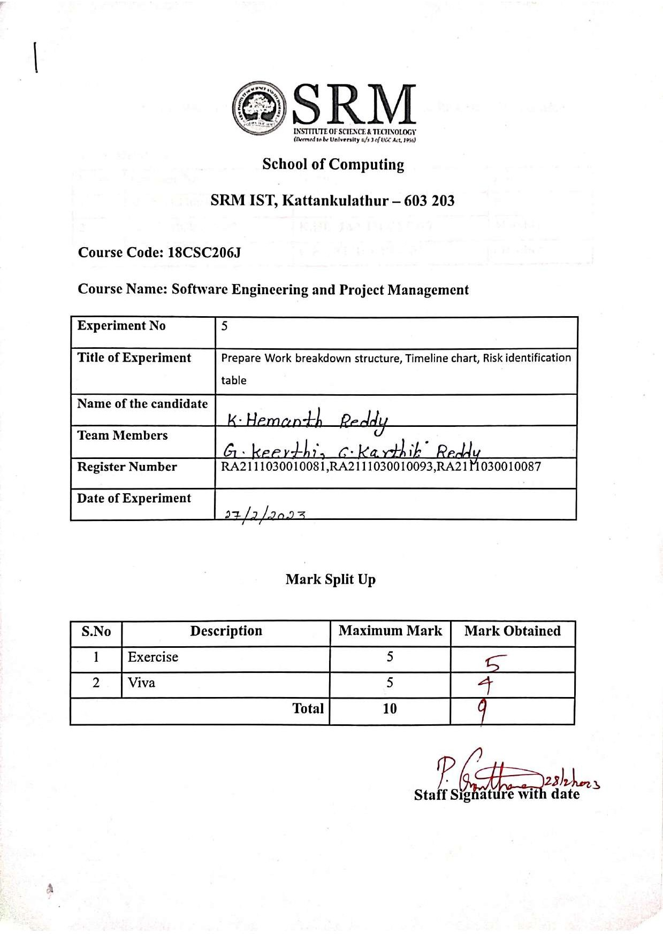

21

#### WORK BREAKDOWN STRUCTURE (WBS) :

* + - **1 Project Management :**
  1. Define project scope
  2. Create project plan
  3. Assign project roles and responsibilities
  4. Develop project schedule

#### 2 Requirements Gathering and Analysis

* 1. Conduct market research to determine customer needs and preferences
  2. Determine features and functionalities of the app
  3. Identify stakeholders and their requirements
  4. Analyze and document requirements

#### 3 Design and Development

* 1. Develop wireframes and prototypes
  2. Design user interface and user experience 3.3Develop the database schema and data models
  3. Implement front-end and back-end development
  4. Integrate payment gateway and third-party services
  5. Perform testing and quality assurance

#### 4 Content Creation

* 1. Write product descriptions
  2. Create visual content for the app
  3. Develop marketing content for social media and email campaigns

#### 5 Deployment and Maintenance

* 1. Deploy the app to production environment
  2. Monitor app performance and user feedback
  3. Address any bugs or issues
  4. Provide ongoing maintenance and updates

#### 6 Customer Support

* 1. Establish customer support channels
  2. Train customer support team
  3. Respond to customer queries and feedback

##### TIMELINE-GANTT CHART:

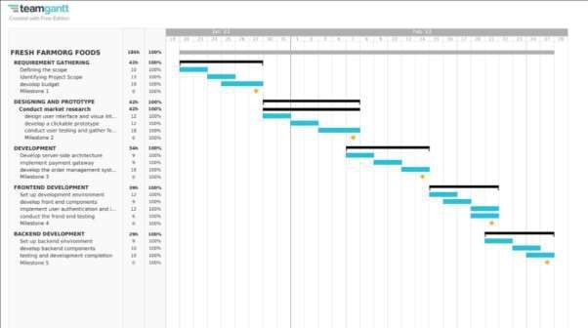

**RISK ANALYSIS-RMMM(RISK MITIGATION MONITORING MANAGEMENT):**

|  |  |  |  |
| --- | --- | --- | --- |
| **RISK** | **RISK DESCRIPTION** | **IMPACT** | **MITIGATION** |
| **Internet and technology risks** | Have a dedicated team to handle technical issuses and ensure prompt resolution of any problems | HIGH | Ensure robust and secure technology infrastructure and have a backup plan in case of technical issues |
| **Perishable** **item spoilage risk** | Have a dedicated team to manage inventory and | MEDIUM | Implement a proper storage transportation |
|  | monitor the freshness of |  | system with proper |
|  | the vegetables |  | temperature control to |
|  |  |  | minimize spoilage |
| **Competition risks** | Continuously update and improve the app to stay ahead of the competition | HIGH | Offer competitive prices and promotions, as  well as unique features  and services to |
|  |  |  | differentiate from |
|  |  |  | competitors |
| **Cybersecurity risks And data breaches** | Have a dedicated team to handle security issues and ensure prompt resolution of any security breaches | HIGH | Implement robust security measures to protect customer data, including encryption and secure payment gateways |
| **Fluctuations** **in vegetable prices** | Develop a contingency plan for sudden price increases or decreases | HIGH | stablish contracts with suppliers to ensure consistent pricing |
| **Changes in government Regulations related to online food**  **delivery** | Have a dedicated team to handle any regulatory issues or changes | MEDIUM | Stay up-to-date on regulatory changes and ensure compliance |

|  |  |  |  |
| --- | --- | --- | --- |
| **Negative reviews or publicity on social media and review sites** | Have a dedicated team to handle customer complaints and feedback | HIGH | Have a dedicated team to handle customer complaints and feedback |

**Resulte:**

Thus, the work breakdown structure with timeline chart and risk table were formulated successfully

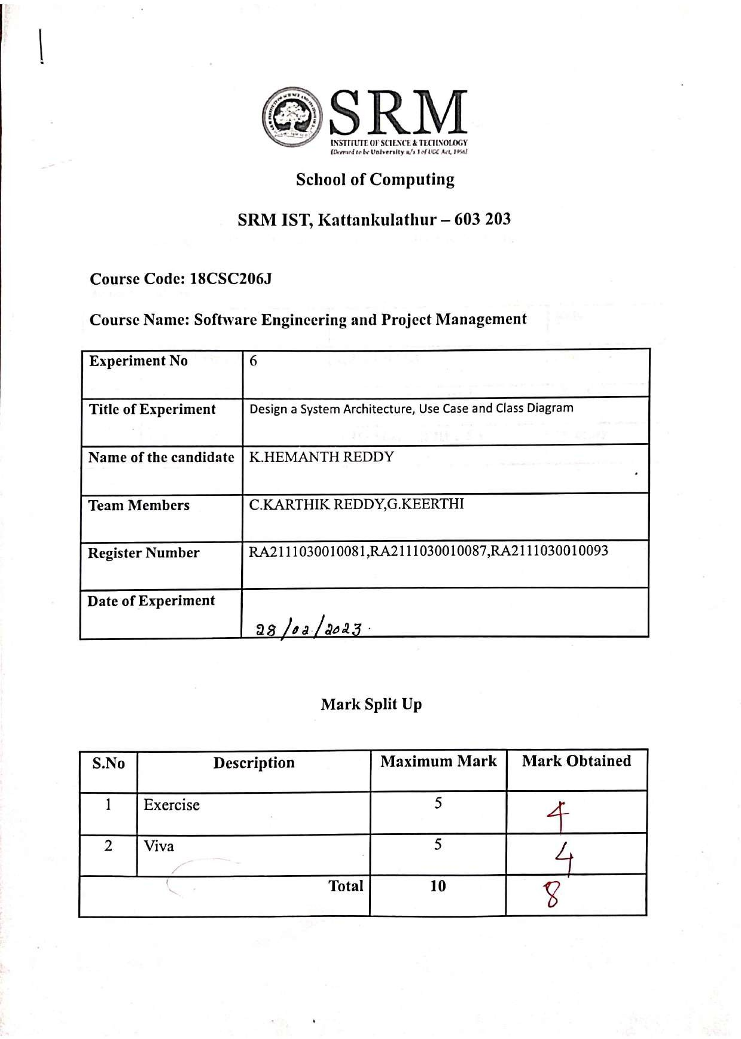

### 26

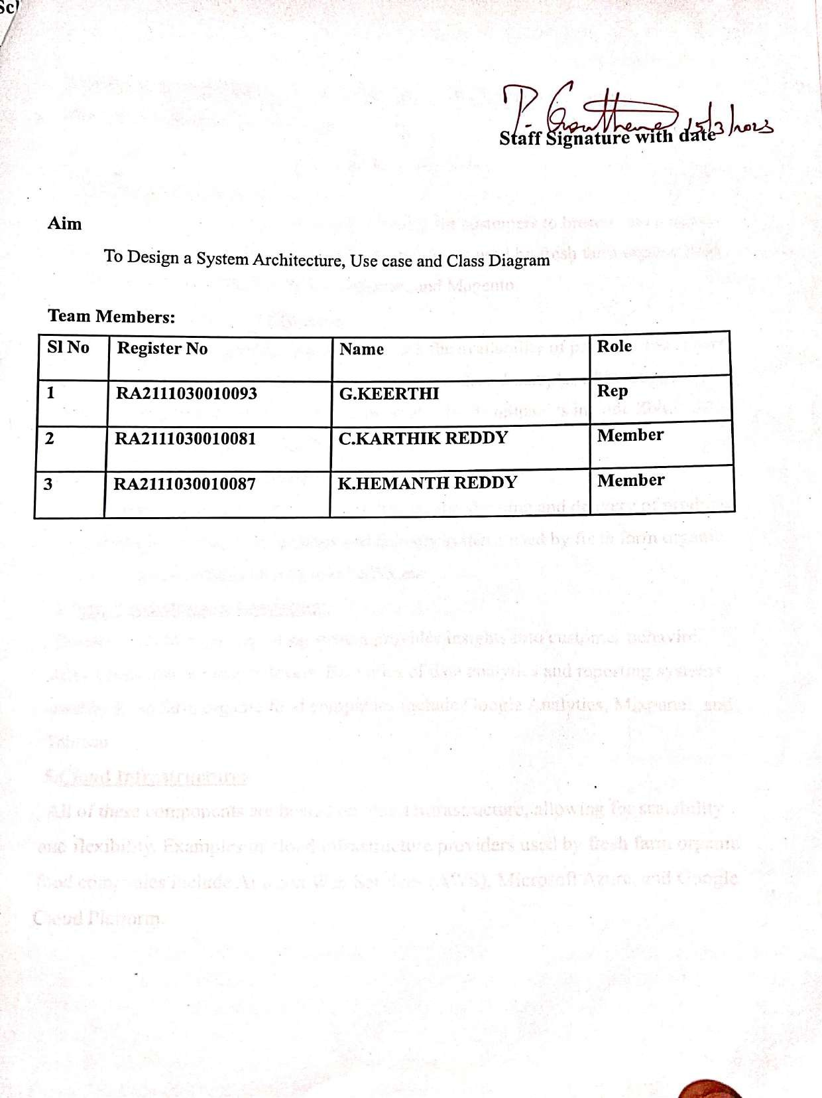

27

## SYSTEM ARCHITECTURE FOR FRESH FARMORG FOODS:

The system architecture for a fresh farm organic food organization would involve a combination of technologies and software applications.

**1.E-commerce Platform:**

The e-commerce platform is the main interface for customers to browse and purchase products online. Examples of e-commerce platforms used by fresh farm organic food companies include Shopify, WooCommerce, and Magento.

#### Inventory Management System:

The inventory management system helps track the availability of products and ensures that there is enough inventory to fulfill customer orders. Examples of inventory management systems used by fresh farm organic food companies include Zoho Inventory, TradeGecko, and DEAR Inventory.

#### Logistics and Delivery System:

The logistics and delivery system helps manage the shipping and delivery of products to customers. Examples of logistics and delivery systems used by fresh farm organic food companies include Dunzo, and FedEx,etc

#### Data Analytics and Reporting:

The data analytics and reporting system provides insights into customer behavior, sales trends, and inventory levels. Examples of data analytics and reporting systems used by fresh farm organic food companies include Google Analytics, Mixpanel, and Tableau.

#### Cloud Infrastructure:

All of these components are hosted on cloud infrastructure, allowing for scalability and flexibility. Examples of cloud infrastructure providers used by fresh farm organic food companies include Amazon Web Services (AWS), Microsoft Azure, and Google Cloud Platform.

## USE CASE DIAGRAM:

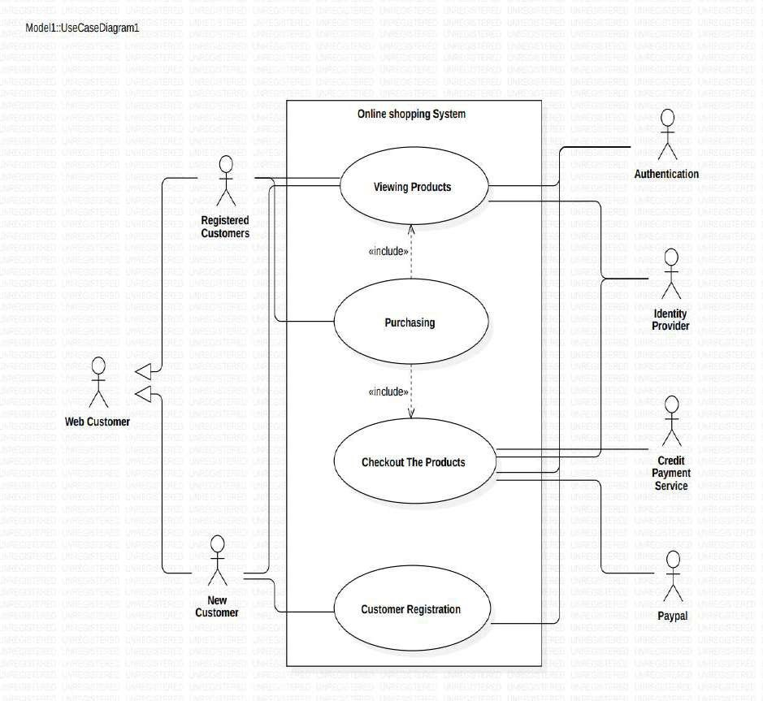

**CLASS DIAGRAM:**

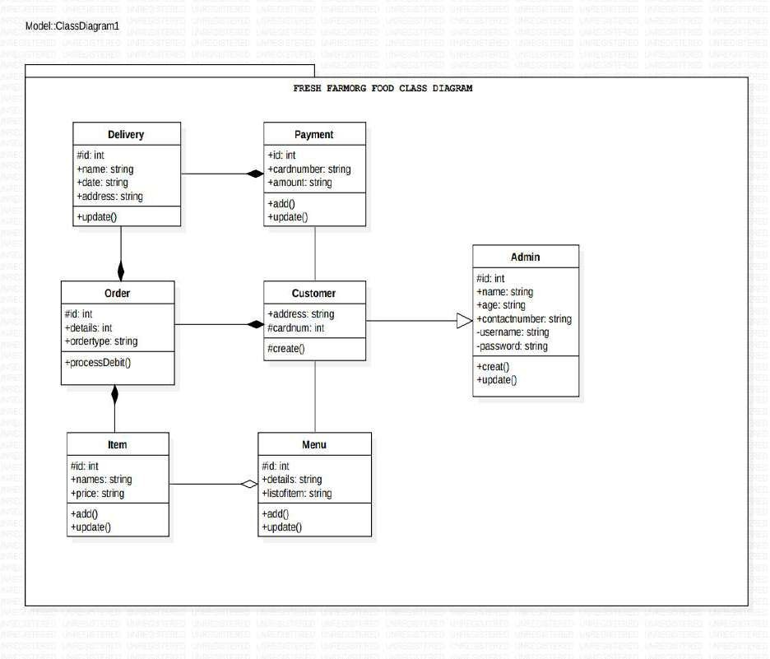

Result:

Thus, the system architecture, use case and class diagram created successfully.



### 31

##### Aim

To create the Entity Relationship Diagram

##### Team Members:

|  |  |  |  |
| --- | --- | --- | --- |
| **S No** | **Register No** | **Name** | **Role** |
| **1** | **RA2111030010093** | **G.KEERTHI** | **Rep** |
| **2** | **RA2111030010087** | **K.HEMANTH REDDY** | **Member** |
| **3** | **RA2111030010081** | **C.KARTHIK REDDY** | **Member** |

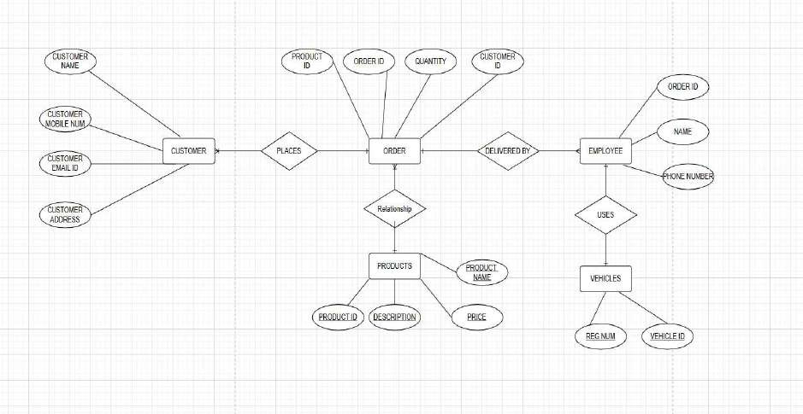**ENTITY RELATIONSHIP DIAGRAM:**

Result:

Thus, the entity relationship diagram was created successfully.

##### Aim

To develop the data flow diagram up to level 1 for the <project name>

ONLINE VEGETABLE DELIVERY SYSTEM

##### Team Members:

|  |  |  |  |
| --- | --- | --- | --- |
| **S No** | **Register No** | **Name** | **Role** |
| **1** | **RA2111030010093** | **G.KEERTHI** | **Rep** |
| **2** | **RA2111030010087** | **K.HEMANTH REDDY** | **Member** |
| **3** | **RA2111030010081** | **C.KARTHIK REDDY** | **Member** |

**Data flow diagram: LEVEL 0:**

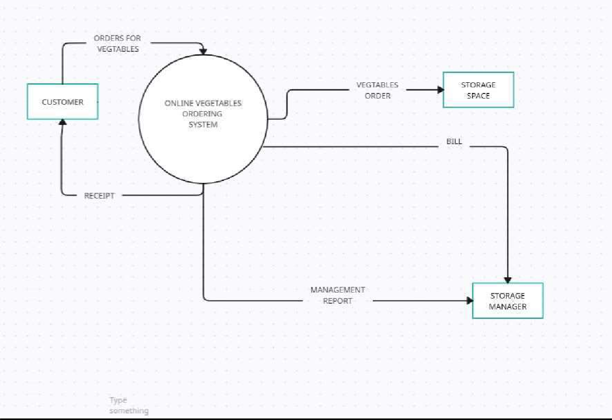

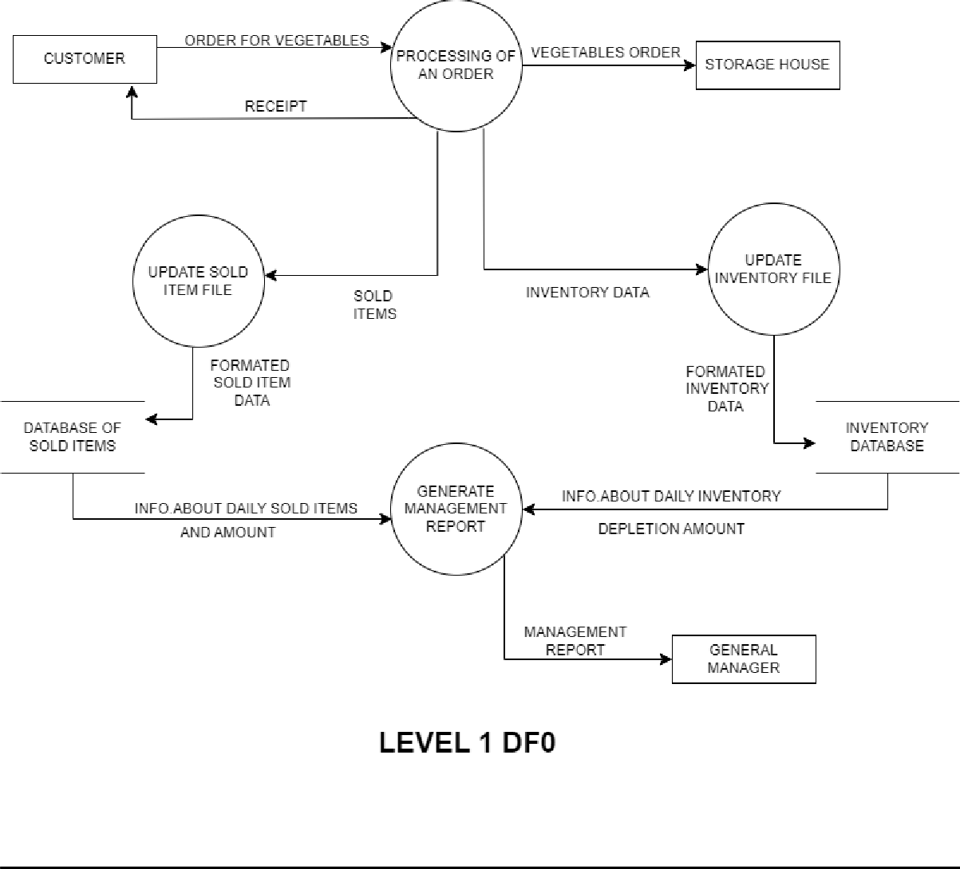

Result:

Thus, the data flow diagrams have been created for the ONLINE VEGETABLE

DELIVERY SYSTEM..

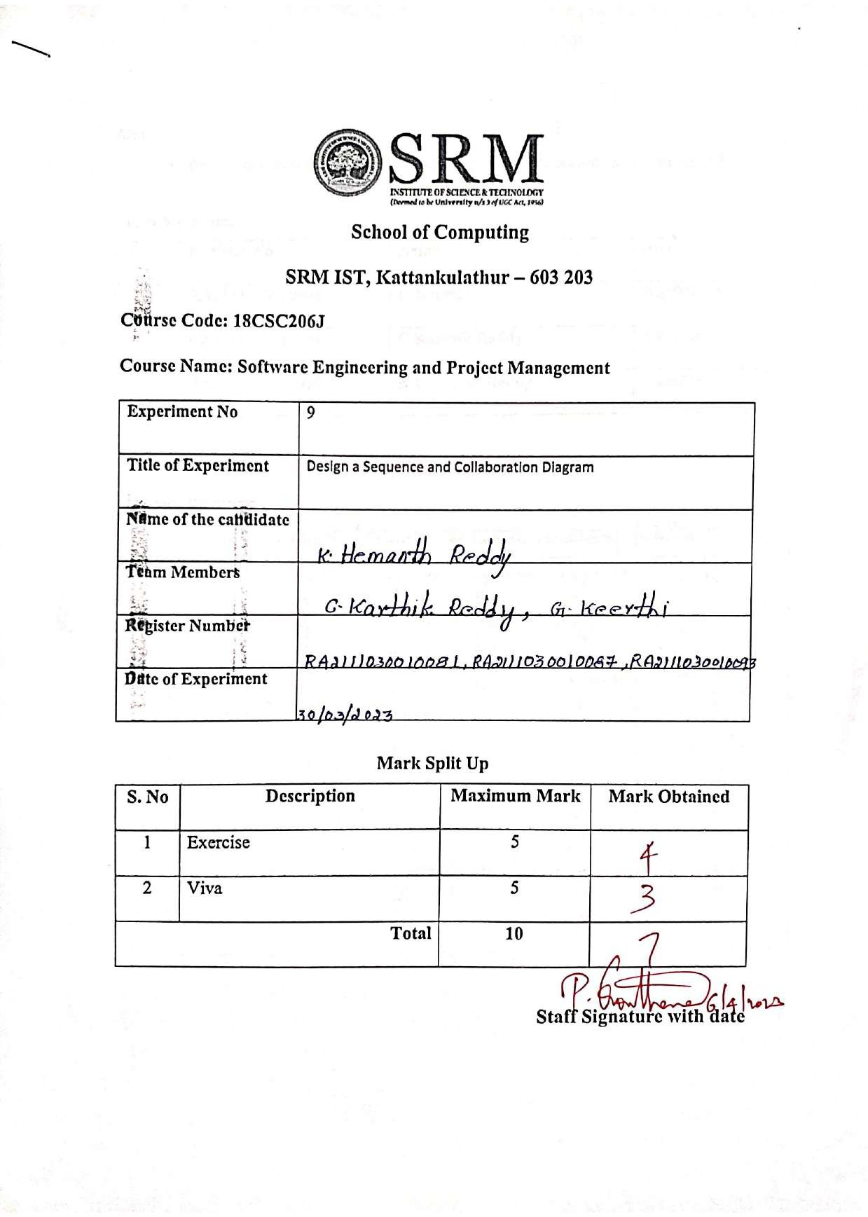

### 35

##### Aim

To create the sequence and collaboration diagram for the security solutions limited.

##### Team Members:

|  |  |  |  |
| --- | --- | --- | --- |
| **S No** | **Register No** | **Name** | **Role** |
| **1** | **RA2111030010093** | **G Keerthi** | **Rep/Member** |
| **2** | **RA2111030010081** | **C Karthik Reddy** | **Member** |
| **3** | **RA2111030010087** | **K Hemanth Reddy** | **Member** |

**Sequence Diagram:**

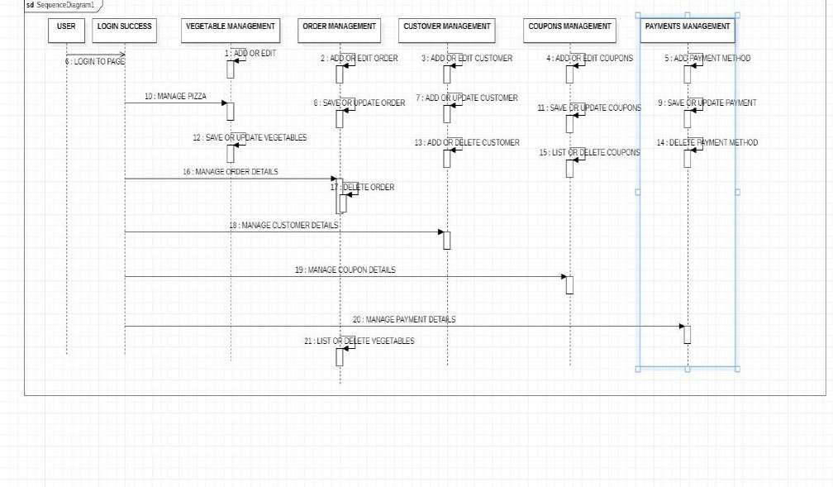

##### Collaboration Diagram:

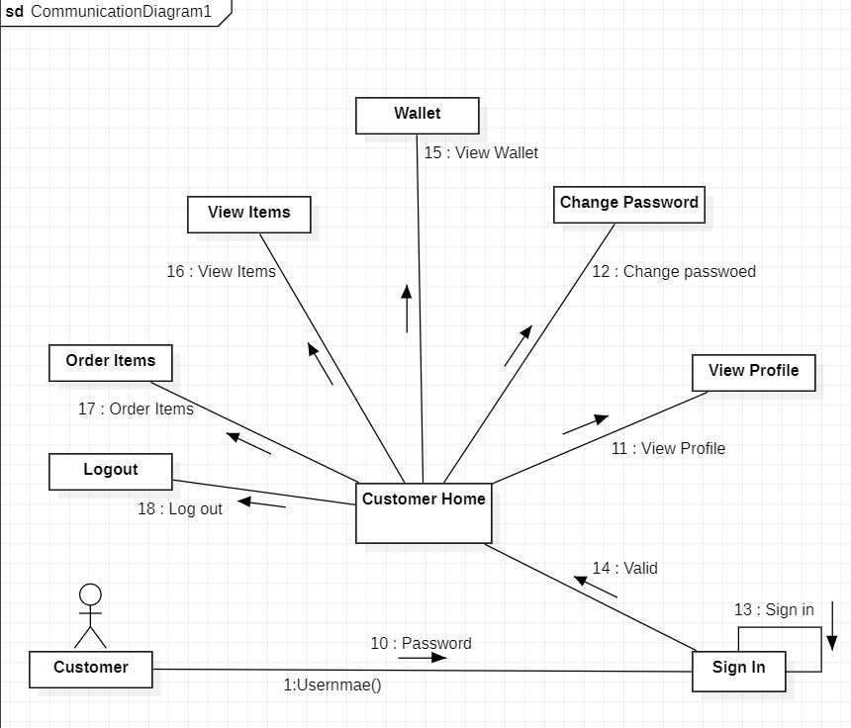

Result:

Thus, the sequence and collaboration diagrams were created for the Security solutions

limited.

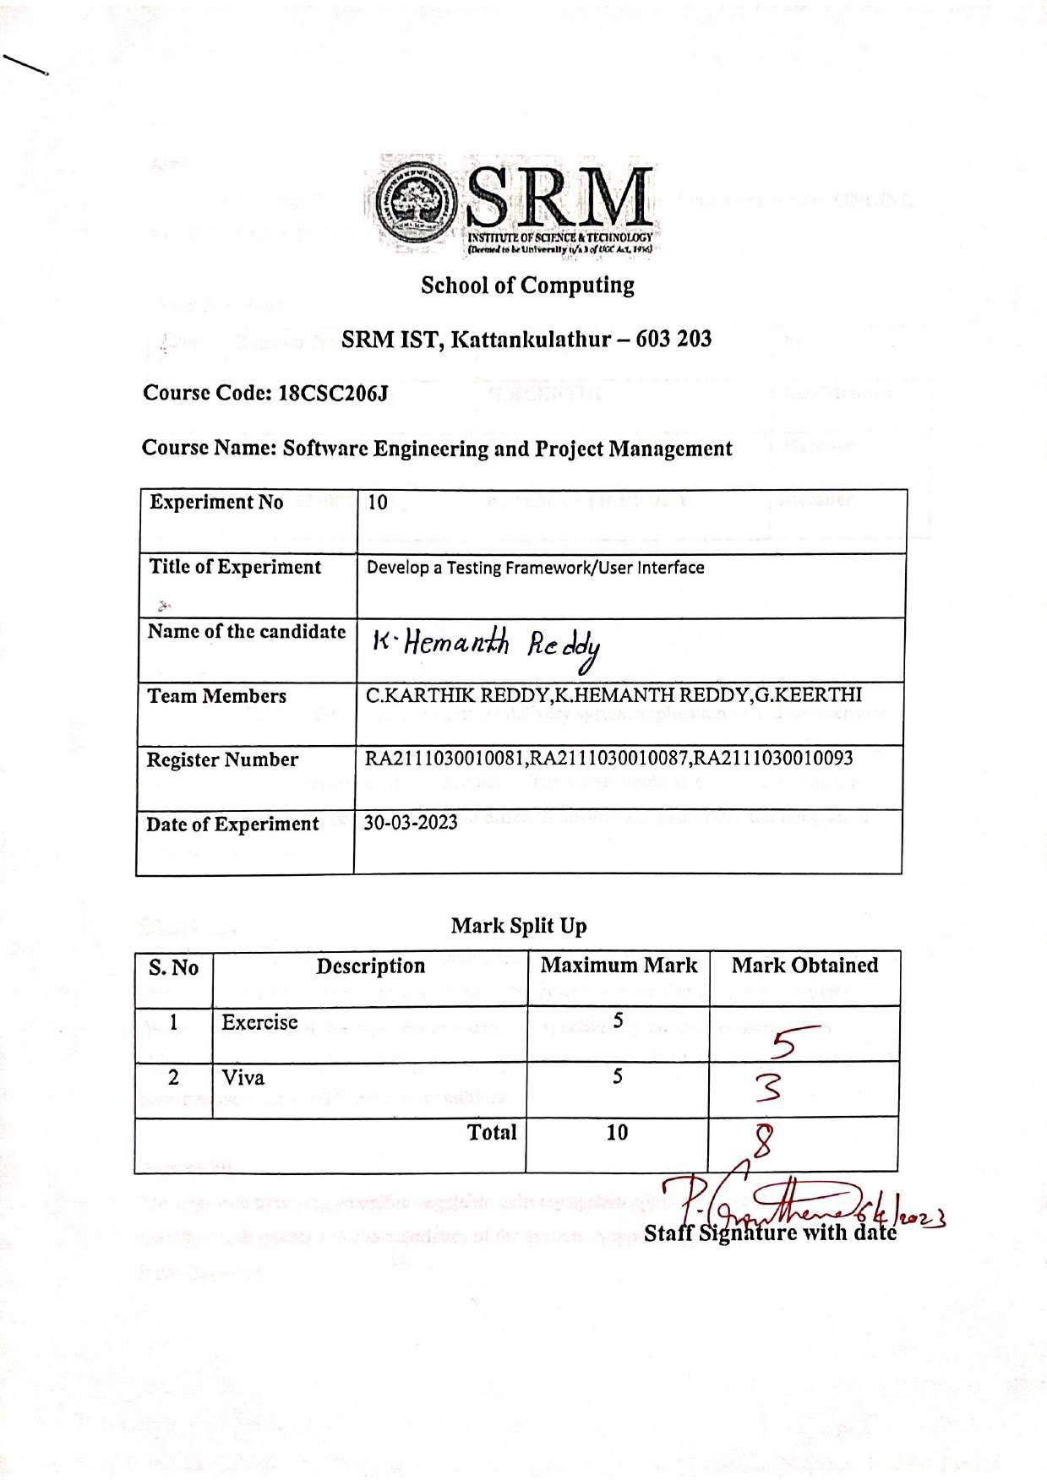

### 38

##### Aim

To develop the testing framework and/or user interface framework for the **ONLINE**

##### VEGETABLE DELIVERY SYSYTEM.

**Team Members:**

|  |  |  |  |
| --- | --- | --- | --- |
| **S No** | **Register No** | **Name** | **Role** |
| **1** | **RA2111030010093** | **G.KEERTHI** | **Rep/Member** |
| **2** | **RA2111030010081** | **C.KARTHIK REDDY** | **Member** |
| **3** | **RA2111030010093** | **K.HEMANTH REDDY** | **Member** |

##### SCOPE:

The scope of testing for an online vegetable delivery system application would be to ensure that the system functions correctly and efficiently, is user-friendly and secure, and meets all the requirements specified by the stakeholders. The scope would also include testing the system's performance, compatibility with different devices and platforms, and integration with other systems.

##### Objectives:

The primary objectives of testing an online vegetable delivery system application would be to identify and eliminate any defects or bugs in the system, ensure that the system is user- friendly, and meets all the business requirements specified by the stakeholders. Other objectives would include verifying that the system is secure, reliable, and scalable, and that it performs well under different load conditions.

##### Approach:

The approach to testing an online vegetable delivery system application would depend on the specific requirements and characteristics of the system. A typical approach would involve the following steps:

Requirements Analysis: Identify the requirements and objectives of the system and define the scope of testing.

**Test Planning**: Develop a test plan that outlines the testing strategy, objectives, scope, and timelines.

**Test Design:** Create test cases and test scenarios that cover all the functionalities of the system.

**Test Execution:** Perform the testing as per the test plan and document any defects or issues that are found.

**Defect Management:** Track and manage the defects found during testing, and ensure that they are resolved before release.

**Test Reporting**: Generate test reports that summarize the testing results and provide feedback on the system's performance, usability, and functionality.

**Retesting:** Verify that all the defects found during testing have been fixed and retest the system to ensure that it is stable and functional.

Overall, the approach to testing an online vegetable delivery system application should be systematic, comprehensive, and collaborative, involving all the stakeholders, including developers, testers, and end-users.

**Test Plan**

**Scope of Testing**

The scope of testing for an online vegetable delivery system would depend on several factors, including the system's requirements, the business goals of the application, and the types of risks and challenges associated with the system.

Some potential areas of testing that could be included in the scope of testing for an online vegetable delivery system might include:

##### Functional testing:

This would involve testing the various functionalities of the system, such as user registration, product search and selection, order placement, payment processing, and delivery tracking.

##### Performance testing:

This would involve testing the system's ability to handle a large number of users and orders, as well as its response time, scalability, and reliability under different load conditions.

##### Security testing:

This would involve testing the system's security measures to ensure that customer data, payment information, and other sensitive data are protected from unauthorized access, hacking, and other security threats.

**Usability testing:** This would involve testing the system's user interface, navigation, and overall user experience to ensure that it is user-friendly and easy to use.

**Compatibility testing:** This would involve testing the system's compatibility with different web browsers, operating systems, and mobile devices to ensure that it works well across different platforms.

**Integration testing:** This would involve testing the system's ability to integrate with third- party systems, such as payment gateways, inventory management systems, and delivery tracking systems.

Overall, the scope of testing for an online vegetable delivery system would need to be comprehensive and cover all aspects of the system to ensure that it is functional, reliable, and secure. It should also take into account the needs and expectations of the end-users and address any potential issues or concerns that could impact the success of the system**.**

**TABULATION OF TYPES OF TESTING, METHODOLOGY AND TOOLS:**

|  |  |  |
| --- | --- | --- |
| Types of Testing | Methodology | Tools Required |
| Functional Testing | Black Box Testing, Regression Testing | Selenium, Test Complete, HP Quick Test Professional |
| Performance Testing | Load Testing , Stress Testing | Apache J Meter, Load Runner, Gating |
| Security Testing | Penetration Testing, Vulnerability Scanning | OWASP ZAP, Nessus, Nmap |
| Usability Testing | User Acceptance Testing, Exploratory Testing | User Testing, Testlio, UXCam |
| Compatibility Testing | Cross-Browser Testing, Cross- Device Testing | Browser stack, Sauce Labs, Cross Browser Testing |
| Integration Testing | API Testing, Service Virtualization | Postman, SoapUI, Virtualize |

Result:

Thus, the testing framework/user interface framework has been created for the **ONLINE VEGETABLE DELIVERY SYSTEM.**

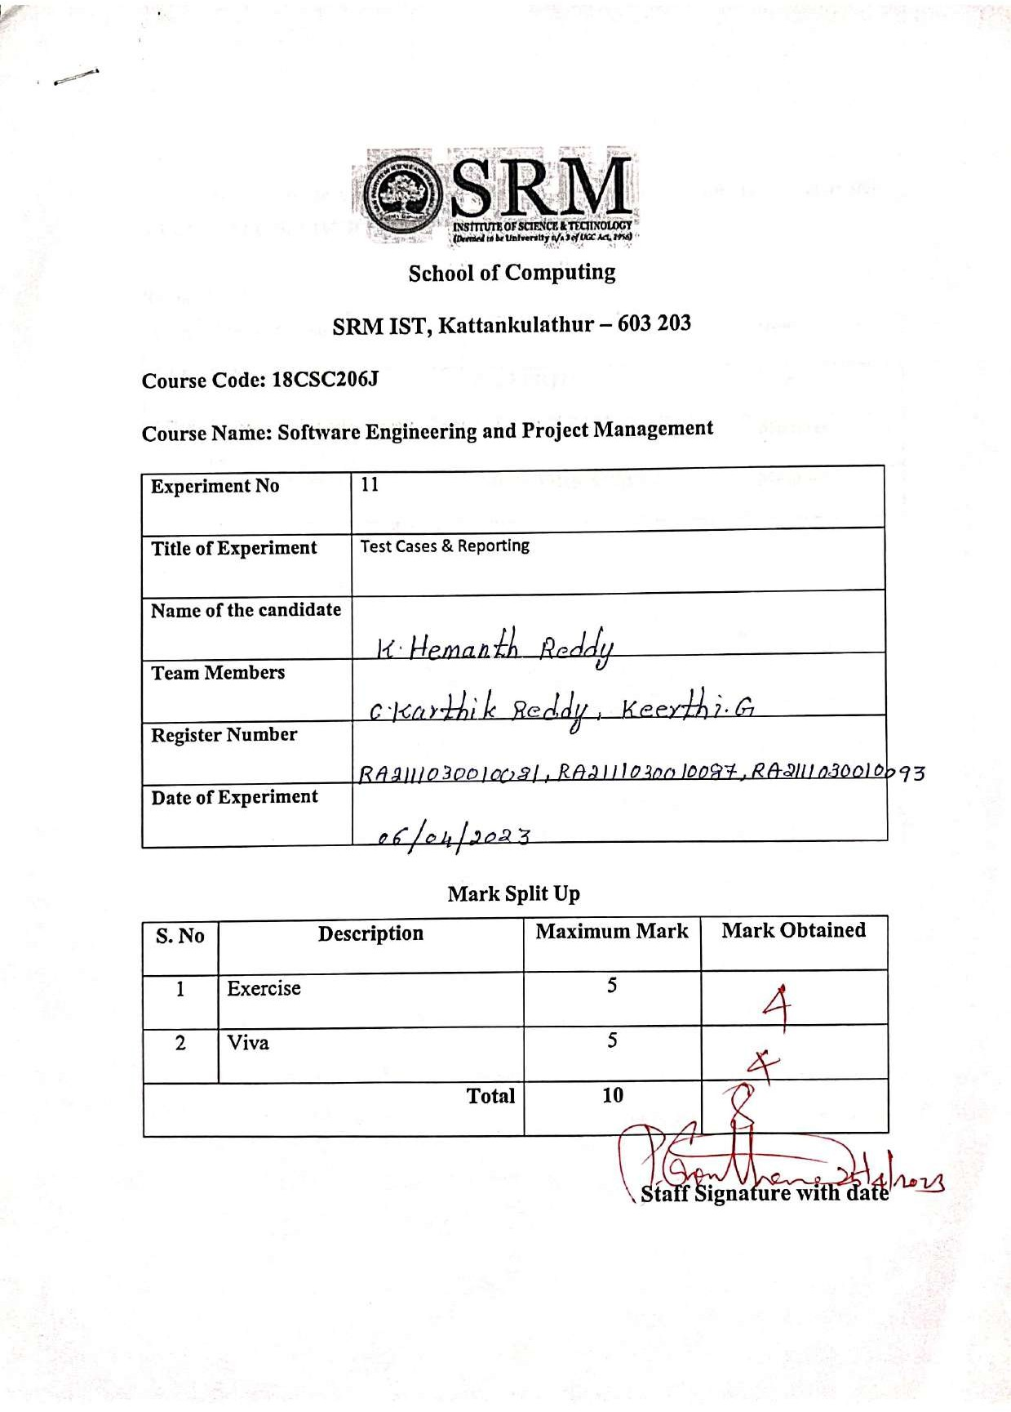

43

##### Aim

To develop the test cases manual with manual test case report for the **ONLINE**

##### VEGETABLE DELIVERY SYSTEM.

**Team Members:**

|  |  |  |  |
| --- | --- | --- | --- |
| **S No** | **Register No** | **Name** | **Role** |
| **1** | **RA2111030010093** | **G.KEERTHI** | **Rep** |
| **2** | **RA2111030010081** | **K.HEMANTH REDDY** | **Member** |
| **3** | **RA2111030010087** | **C.KARTHIK REDDY** | **Member** |

##### Test Scenario:[CATEGORIES FUNCTION]

Verify that the categories feature of the online vegetable delivery system displays all available categories correctly.

**Preconditions:** The user has access to the internet and the online vegetable delivery system website.

##### Execution steps:

* + Open the online vegetable delivery system website/application.
  + Navigate to the categories feature.
  + Verify that all available categories are displayed correctly.
  + Verify that the category images are displayed clearly.
  + Verify that the names of the categories are spelled correctly.
  + Verify that the categories are properly aligned and formatted.
  + Verify that the categories are listed in alphabetical order.
  + Verify that the categories are clickable and lead to the correct products.

##### Expected Outcome:

All available categories should be displayed correctly with clear images, correct spelling, proper alignment, alphabetical order, and clickable links that lead to the correct products. **Remarks:**

The categories feature of the online vegetable delivery system was tested successfully with no issues found.

##### Obstacles to Proceed Further:

One potential obstacle that may hinder further testing of the categories feature is if new categories are added to the system without proper documentation or notification. This may result in incomplete or inaccurate testing results.

##### Seek Help from Stakeholders:

To avoid this obstacle, it would be helpful to collaborate with the stakeholders responsible for managing the categories feature and request proper documentation and notification whenever new categories are added to the system.

##### Test Scenario: [SEARCH FUNCTIONALITY]

Search functionality should work properly for the online vegetable delivery system.

##### Execution Steps:

* + Navigate to the homepage of the online vegetable delivery system.
  + Click on the search bar.
  + Type the name of a vegetable that is available on the website.
  + Press enter or click on the search button.
  + Verify that the search results are displayed.
  + Repeat steps 2-5 for different vegetable names.
  + Type a vegetable name that is not available on the website.
  + Press enter or click on the search button.
  + Verify that the search results indicate that the vegetable is not found.

##### Expected Outcome:

The search functionality should work properly.

The search results should display all the available vegetables that match the search criteria. If the vegetable is not available on the website, the search results should indicate that the vegetable is not found.

##### Remarks:

The search functionality for the online vegetable delivery system works as expected.

##### Obstacles:

During testing, there were some instances where the search results took longer than expected to load, causing delays in testing.

Some search queries did not yield accurate results, which needs to be addressed to improve the search functionality.

##### Seeking help:

The development team should be informed of the issues faced during testing and be requested to investigate and fix any issues related to the search functionality.

The stakeholders should be notified of the potential impact of the search functionality issues on the user experience and business goals**.**

##### Test scenario:[ORDER TRACKING]

This test case is to ensure that the customers are able to track their orders on the online vegetable delivery system.

##### Pre-conditions:

The customer has placed an order on the online vegetable delivery system. The customer has received an order confirmation with a unique order ID. The order status is "processing" or "shipped".

##### Test Steps:

* + Navigate to the online vegetable delivery system's homepage.
  + Click on the "Order Tracking" link.
  + Enter the unique order ID received in the order confirmation email.
  + Click on the "Track Order" button.
  + Verify that the current order status is displayed.
  + Verify that the estimated delivery date is displayed.
  + Verify that the shipping carrier's name and tracking number are displayed.
  + Verify that the customer's shipping address is displayed.

##### Expected Result:

The customer should be able to track their order and view the current status, estimated delivery date, shipping carrier's name and tracking number, and the customer's shipping address**.**

##### Actual Result:

The customer is unable to track their order and view the current status, estimated delivery date, shipping carrier's name and tracking number, and the customer's shipping address. The system displays an error message "Order not found".

##### Obstacles to Proceed Further:

Technical issue with the order tracking feature. Insufficient data entry or system configuration.

Limited integration between the online vegetable delivery system and the shipping carrier's tracking system.

##### Seeking help from stakeholders:

IT team to investigate and resolve the technical issue with the order tracking feature. Customer service team to verify the order data entry and system configuration.

Shipping carrier's team to improve the integration with the online vegetable delivery system.

##### Functional Test Cases:

|  |  |  |  |  |  |  |
| --- | --- | --- | --- | --- | --- | --- |
| **Test**  **ID** | **Test**  **Scenario** | **Test cases** | **Execution**  **Steps** | **Execution**  **Outcomes** | **Actual**  **Outcome** | **Status/**  **Remarks** |
| FT- 01 | User- Registration | Successful Registration | 1. Navigation to the registration page. 2. Enter valid details and click on the Register   button | User should be successfully registered and redirected to the login page. | User is successfully registered and redirected to the login page | Pass |
| FT- 02 | User login | Successful Login | 1. Navigation to the Login page.  2 .Enter valid Login credentials and click on the Login button. | User should be successfully registered and redirected to the dashboard. | User is successfully registered and redirected to dashboard. | Pass |
| FT- 03 | Search Function | Search for Vegetables | 1. Navigation to the Search bar. 2. Select the name of the vegetable and click on the search button | Search results to be displayed with the relevant Vegetables. | Search results are displayed with the relevant vegetables. | Pass |

|  |  |  |  |  |  |  |
| --- | --- | --- | --- | --- | --- | --- |
| FT- 04 | Add to cart | Add Vegetables to cart | 1. Navigate to the vegetable page. 2. Select the desired vegetable and click on the add to the cart   button. | The selected vegetables should be added to the cart. | The selected vegetables are added to the cart. | Pass |
| FT- | Checkout | Complete | 1.Navigation | The order | The order is | Pass |
| 05 | process | Checkout | to the | should be | successfully |  |
|  |  | process | checkout | successfully | placed and the |  |
|  |  |  | page. | placed and the | user receives |  |
|  |  |  | 2. Enter valid | user should | an order |  |
|  |  |  | details and | receive an | confirmation. |  |
|  |  |  | click on the | order |  |  |
|  |  |  | place order | confirmation. |  |  |
|  |  |  | button. |  |  |  |

**Non-Functional Test Cases:**

|  |  |  |  |  |  |  |
| --- | --- | --- | --- | --- | --- | --- |
| Test  ID | Test Scenario | Test Cases | Execution  Steps | Expected  Outcomes | Actual  Outcomes | Status/  Remarks |
| NF- 01 | Usability | Navigation | Navigation through the website using different device and browsers. | Navigation should be smooth and consistent across all devices and  areas | Navigation is smooth and consistent | Pass |
| NF- 02 | Performance | Response Time | Measure the response time of the website on different devices and browsers. | The website should load within 2-3 seconds | The Website takes more than 3 seconds to load on same  devices | Fail-Needs Improvement |
| NF- 03 | Security | Login Authentication | Attempt to login using incorrect credentials | -The website should not allow access with incorrect  credentials | The website denies access with incorrect credentials | Pass |
| NF- 04 | Compatibility | Browser Compatibility | Test Website functionally on different browsers such as chrome Firefox safari,  etc. | Website should be compatible with major browsers. | Website is compatible with major browsers. | Pass |

|  |  |  |  |  |  |  |
| --- | --- | --- | --- | --- | --- | --- |
| NF- 05 | Reliability | Server Downtime | Simulate server downtime and measure the time it takes for the website  to recover | Website should recover within a reasonable time frame | Website recovers quickly from serve downtime | Pass |
| NF- 06 | Scalability | Load Testing | Simulate a large number of users accessing the website simultaneously | The website should be able to handle the load without crashing | The website slows down and some features become un- Responsive with a large number of  users | Pass |

Result:

Thus, the test case manual and report has been created for the **Online Vegetable**

##### Delivery System.



Staff Signature with date

School of Computing

SRM IST, Kattankulathur – 603 203

Course Code: 18CSC206J

Course Name: Software Engineering and Project Management

|  |  |
| --- | --- |
| Experiment No | 12 |
| Title of Experiment | Provide the details of Architecture Design/Framework/Implementation |
|  |  |
| Team Members |  |
| Register Number |  |
| Date of Experiment |  |

Mark Split Up

|  |  |  |  |
| --- | --- | --- | --- |
| S. No | Description | Maximum Mark | Mark Obtained |
| 1 | Exercise | 5 |  |
| 2 | Viva | 5 |  |
|  | TOTAL | 10 |  |

Aim

To provide the details of architectural design/framework/implementation

Team Members:

|  |  |  |  |
| --- | --- | --- | --- |
| S No | Register No | Name | Role |
| 1 | RA2111030010093 | G.KEERTHI | Rep/Member |
| 2 | RA2111030010081 | C.KARTHIK REDDY | Member |
| 3 | RA2111030010087 | K.HEMANTH REDDY | Member |

##### ARCHITECTURAL DESIGN:

An online vegetable delivery system typically follows a client-server architecture, where the client is the user interface and the server provides the backend functionality. The client-side can be a web application or a mobile application that allows customers to browse, search, and order vegetables. The server-side consists of a web server, application server, and database server. The web server handles HTTP requests and responses, while the application server processes the business logic, such as order management, payment processing, and delivery scheduling. Thedatabase server stores and retrieves customer, product, and order data. The system can also include integration with third-party services for payment processing, delivery tracking, and customer support. Overall, the architectural design for an online

vegetable delivery system should prioritize scalability, security, and usability for both customers and administrator

##### FRAMEWORK DESIGN:

The framework design for an online vegetable delivery system typically involves a combination of front-end and back-end frameworks to enable efficient and reliable development. For the front-end, popular frameworks such as React, Vue.js, or Angular can be used to create a responsive and interactive user interface for customers to browse and order vegetables. For the back-end, frameworks such as MYSQL can be used to build the application logic and integrate with databases and third-party services. The framework design should prioritize modularity, scalability, and maintainability, which allows developers to easily add new features and adapt tochanging requirements. Additionally, the use of testing frameworks such as Jest, Pytest, or Mocha can help ensure the reliability and correctness of the system.

Overall, the framework design for an online vegetable delivery system should balance the needs of the user experience, system functionality, and developmentefficiency.

##### PRODUCT CATALOUGE MODULE:

The framework design for an online vegetable delivery system typically involves a combination of front-end and back-end frameworks to enable efficient and reliable development. For the front-end, popular frameworks such as React, Vue.js, or Angular can be used to create a responsive and interactive user interface for customers to browse and order vegetables. For the back-end, frameworks such asDjango, Flask, or Node.js can be used to build the application logic and integrate with databases and third-party services.

The framework design should prioritize modularity, scalability, and maintainability, which allows developers to easily add new features and adapt to changing requirements.

Additionally, the use of testing frameworks such as Jest, Pytest, or Mocha can help ensure the reliability and correctness of the system. Overall, the framework design for an online vegetable delivery system should balance the needs of the user experience, system functionality, and development efficiency

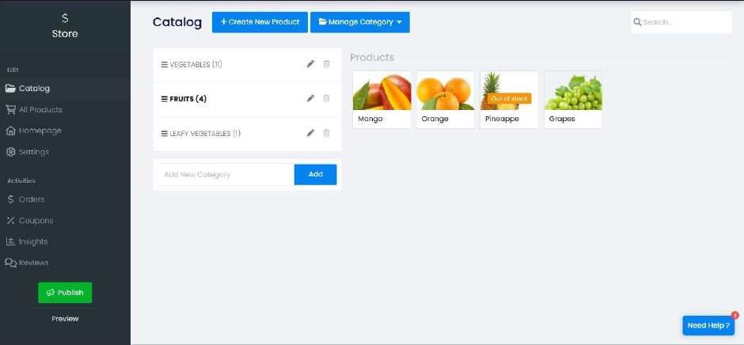

##### Order Management module:

Order management for an online vegetable delivery system typically involves the efficient processing of customer orders from placement to delivery. The order management system should validate customer information, confirm payment, and schedule the delivery based on the customer's preferred date and time. The system should also allow administrators to view and manage orders, including the ability to edit or cancel orders, assign delivery drivers, and generate reports. The order management system can be integrated with other systems such as the productcatalogue and payment gateway to ensure accurate and timely processing of orders.Additionally, the order management system should provide customers with updates on the status of their orders, such as order confirmation, payment receipt, and delivery updates. Overall, a well-designed order management system is essential foran online vegetable delivery system to ensure timely and accurate fulfillment of customer orders.

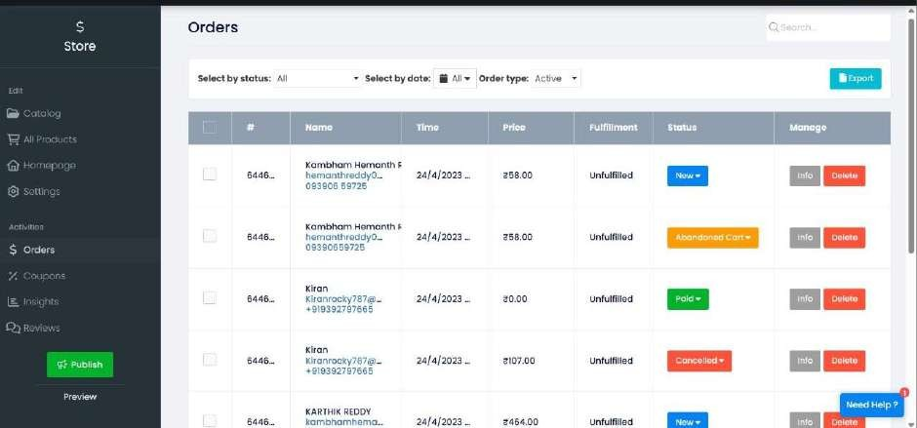

##### CUSTOMER SUPPORT MODULE:

Customer support for an online vegetable delivery system typically involves providingvarious channels for customers to receive assistance and address any issues they may encounter. This can include a help center or knowledge base that contains answers to frequently asked questions, a chatbot or live chat feature that allows customers to communicate with support agents in real-time, and email or phone support for more complex issues. The customer support system should also be integrated with the order management system to provide agents with access to customer orders, delivery status, and other relevant information. Additionally, the customer support system can include tools for administrators to track customer inquiries, monitor response times, and identify areas for improvement. The customer support system should prioritize timely and effective communication, accurate and helpful responses, and a positive customer experience. Overall, a robust customer support system is essential for an online vegetable delivery system to build trust and loyalty with its customers.

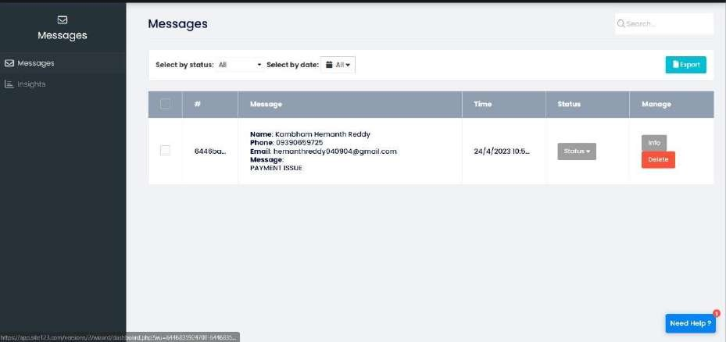

Result:

Thus, the details of architectural design/framework/implementation along withthe

screenshots were provided.

##### CONCLUSION:

In conclusion, the advent of online vegetable delivery systems has revolutionized the way people purchase and consume fresh produce. These services provide an efficient and convenient way for busy individuals to get access to a wide range of high-quality vegetables without leaving their homes. The ability to order online and have fresh produce delivered directly to one's doorstep has made it easier than ever before to maintain a healthy diet and support local farmers. With the added benefits of customization, affordability, and

sustainability, online vegetable delivery systems are becoming an increasingly popular choice for consumers who value quality, convenience, and efficiency. Overall, the emergence of this innovative approach to vegetable delivery has truly transformed the way people shop for fresh produce and has created a more sustainable and efficient food system for the future.

##### REFERENCE:

1.) [How to Start Online Fruit and Vegetables Delivery Business with an App (goteso.com)](https://www.goteso.com/blog/how-to-start-online-fruit-and-vegetable-delivery-business-with-an-on-demand-app/)

2).[My Projects (Active, Page 1) | TeamGantt](https://app.teamgantt.com/my-projects/active/pages/1)

3).[StarUML](https://staruml.io/)

4).[freshfarmorg.com (7884177)- Editor - SITE123](https://app.site123.com/manager/wizard.php?wu=6446835924700-6446835924701-6446835924702&from=dash)

**5).**[**https://freshindiaorganics.com/**](https://freshindiaorganics.com/)

**APPENDIX:**

An appendix for an online vegetable delivery system could include:

List of Vegetables: A comprehensive list of vegetables available for purchase on the platform.

Delivery Zones: A map or list of areas where the online vegetable delivery system provides its services.

Pricing: A clear and detailed breakdown of the pricing structure, including delivery fees, minimum order amounts, and any additional charges.

Delivery Schedule: A schedule of delivery days and times for different locations, as well as cut-off times for ordering.

Payment Options: A list of payment methods accepted by the online vegetable delivery system, including credit and debit cards, PayPal, and other online payment systems.

Refund Policy: A clear statement outlining the refund policy for damaged, spoiled, or incorrect deliveries.

Customer Support: Contact information for customer support, including email, phone, and chat support.

FAQs: A list of frequently asked questions with answers to common queries about the online vegetable delivery system, including information about order tracking, returns, and

cancellations.

Privacy Policy: A statement outlining the online vegetable delivery system's privacy policy, including information about data collection and use, and customer data protection.

Terms and Conditions: A set of terms and conditions governing the use of the online

vegetable delivery system, including information about liability, warranties, and intellectual property rights.